**Protocol for running 7 tesla MRI scanner**

**How to start:**

1. Turn the power gauge to ON.

1. Press standby and let it to turn into solid orange/yellow light
2. Then press ON button and wait until it turns into solid green.
3. Open “ParaVision 360” software from the desktop of “Bruker” computer.

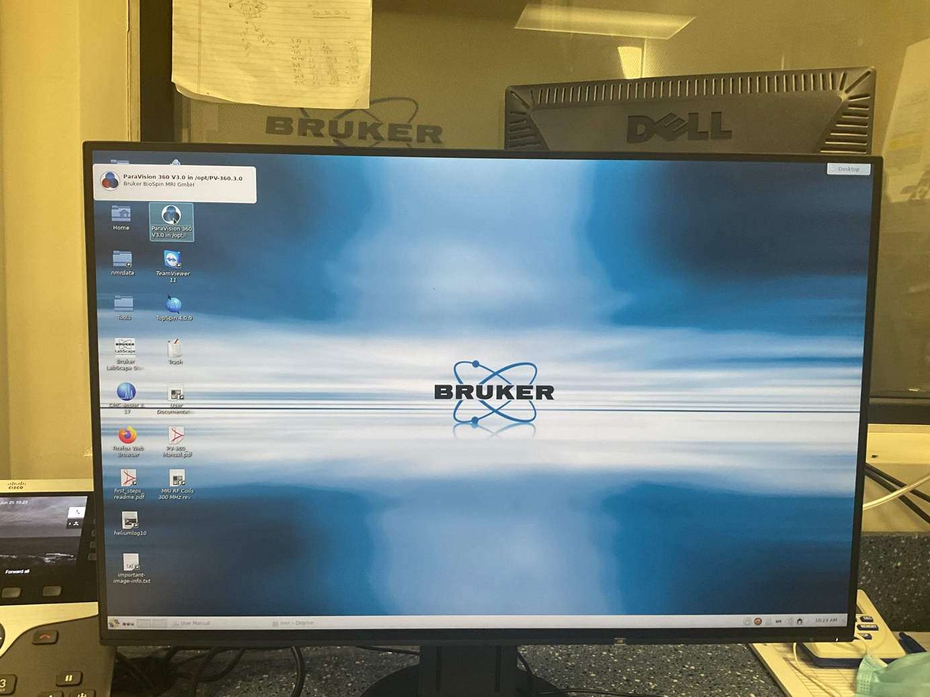

1. Allow the software to load up and DO NOT close any of the windows that automatically opens.

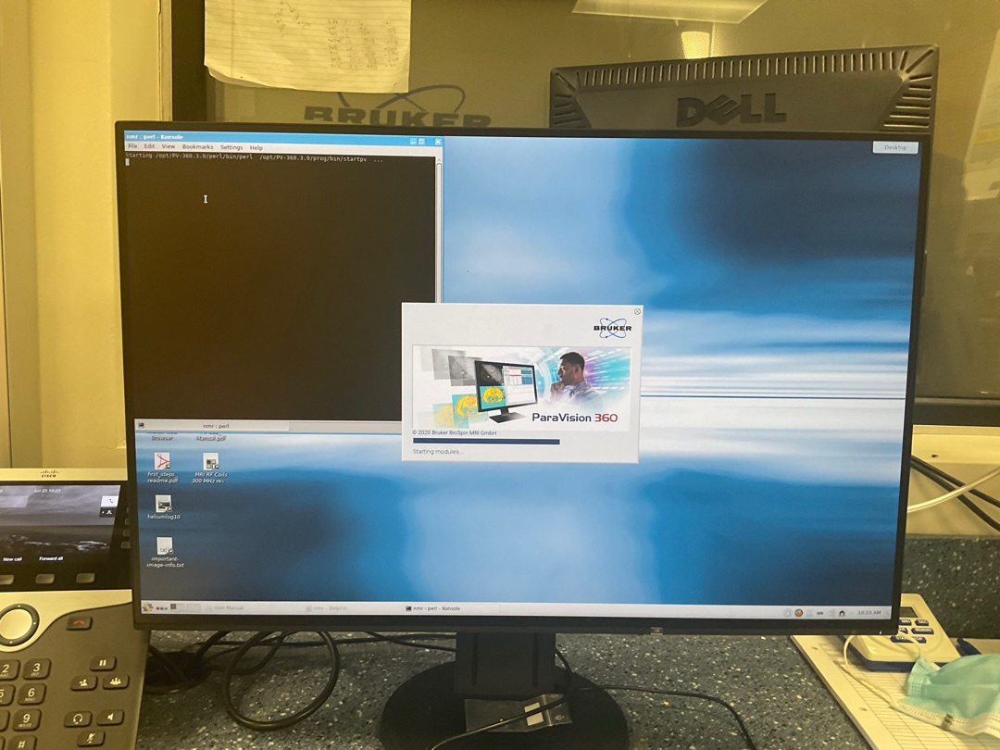

1. When the software is completely loaded, go **:**

* Files >> New >> Study

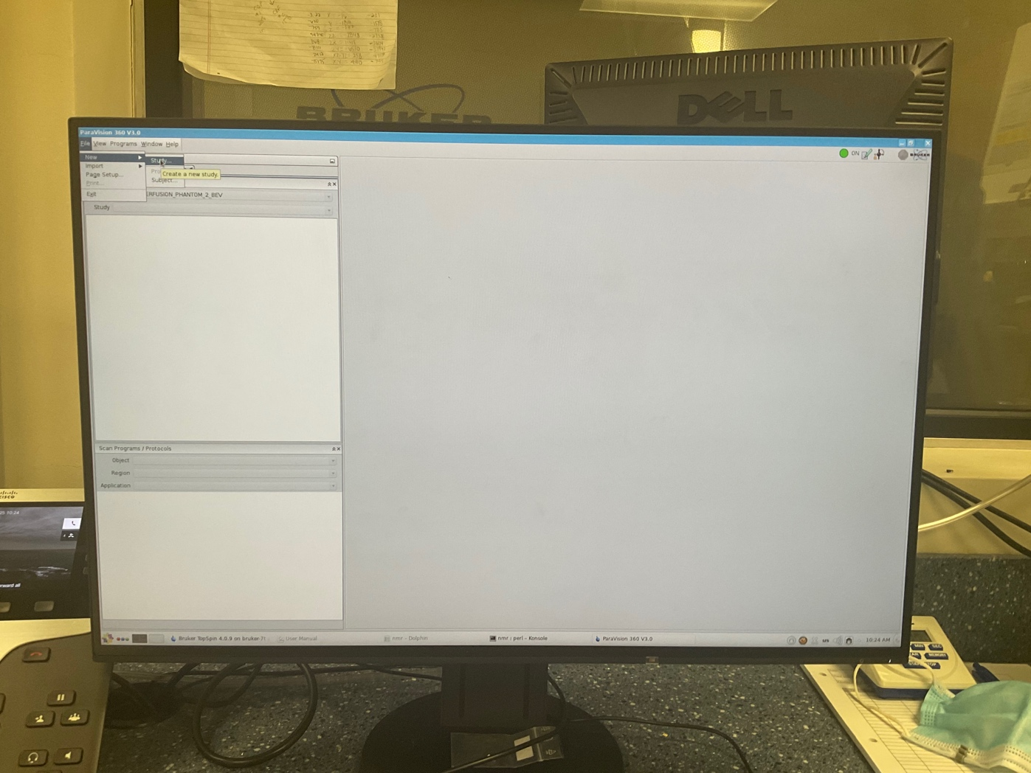

1. Fill the required tabs shown in **bold.**

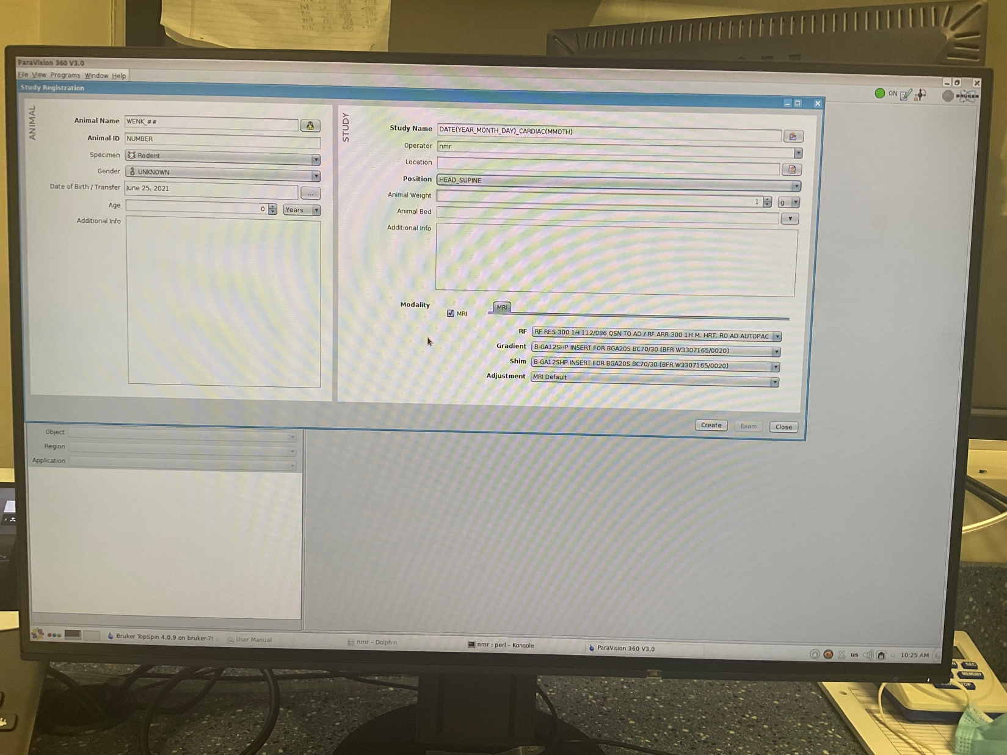

* **Animal Name:** WENK_month_day_year_scan#
* **Animal ID: WENK_**Animal_number
* **Study Name:** WENK_HCM_R403Q
* **Position:** HEAD_SUPINE

1. Click >> Create >> Exam
2. From “Scan Program / Protocols” tab on the left hand side, select **user** protocol

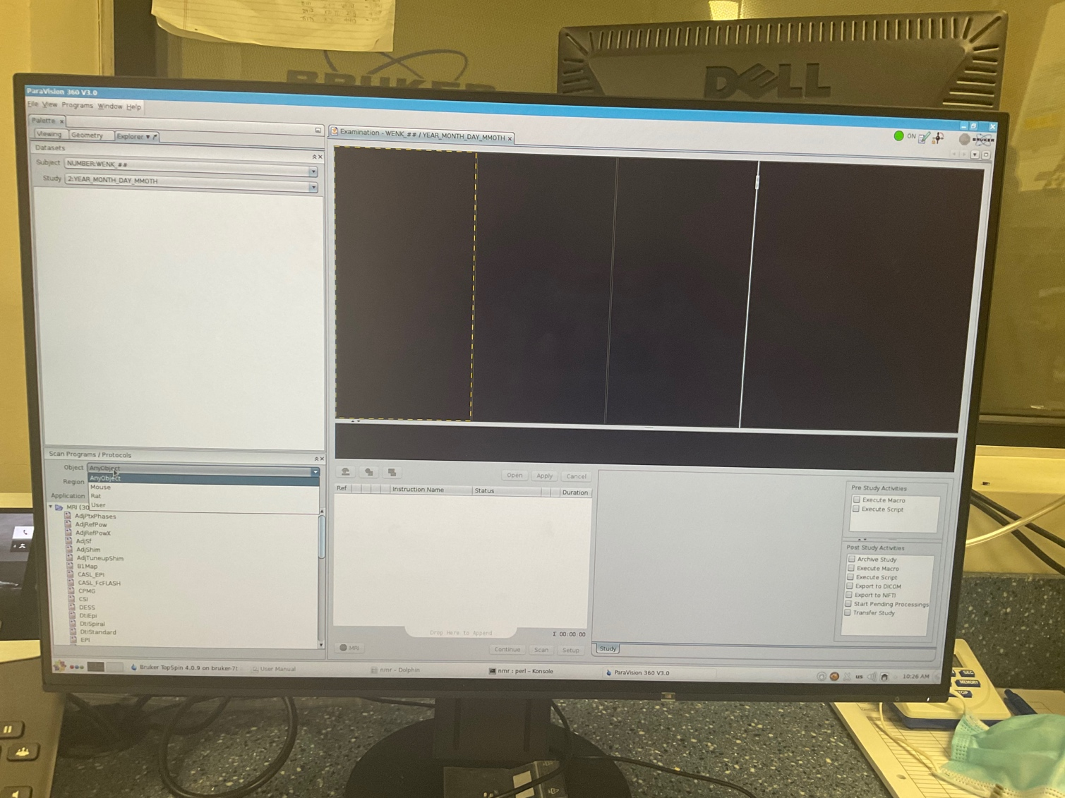

1. From “Scan Program / Protocols” tab on the left hand side,
2. Select **user** protocol in the “**object**” drop down
3. Select “**Region**”, it should be user-defined protocol for this specific study.
4. Select “Heart” for “Application”.

11- Select the "**localizer**” step from the left_down panel and drag it to middle_down panel.

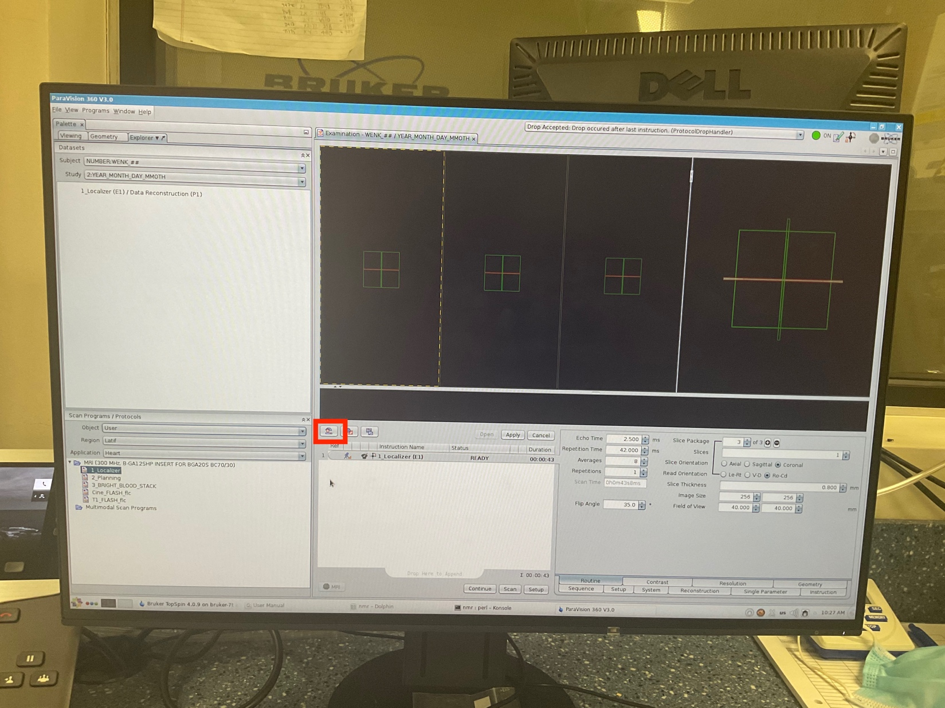

1. Then click on the enclosed icon to open the menu for adjusting the “**wobble**”.

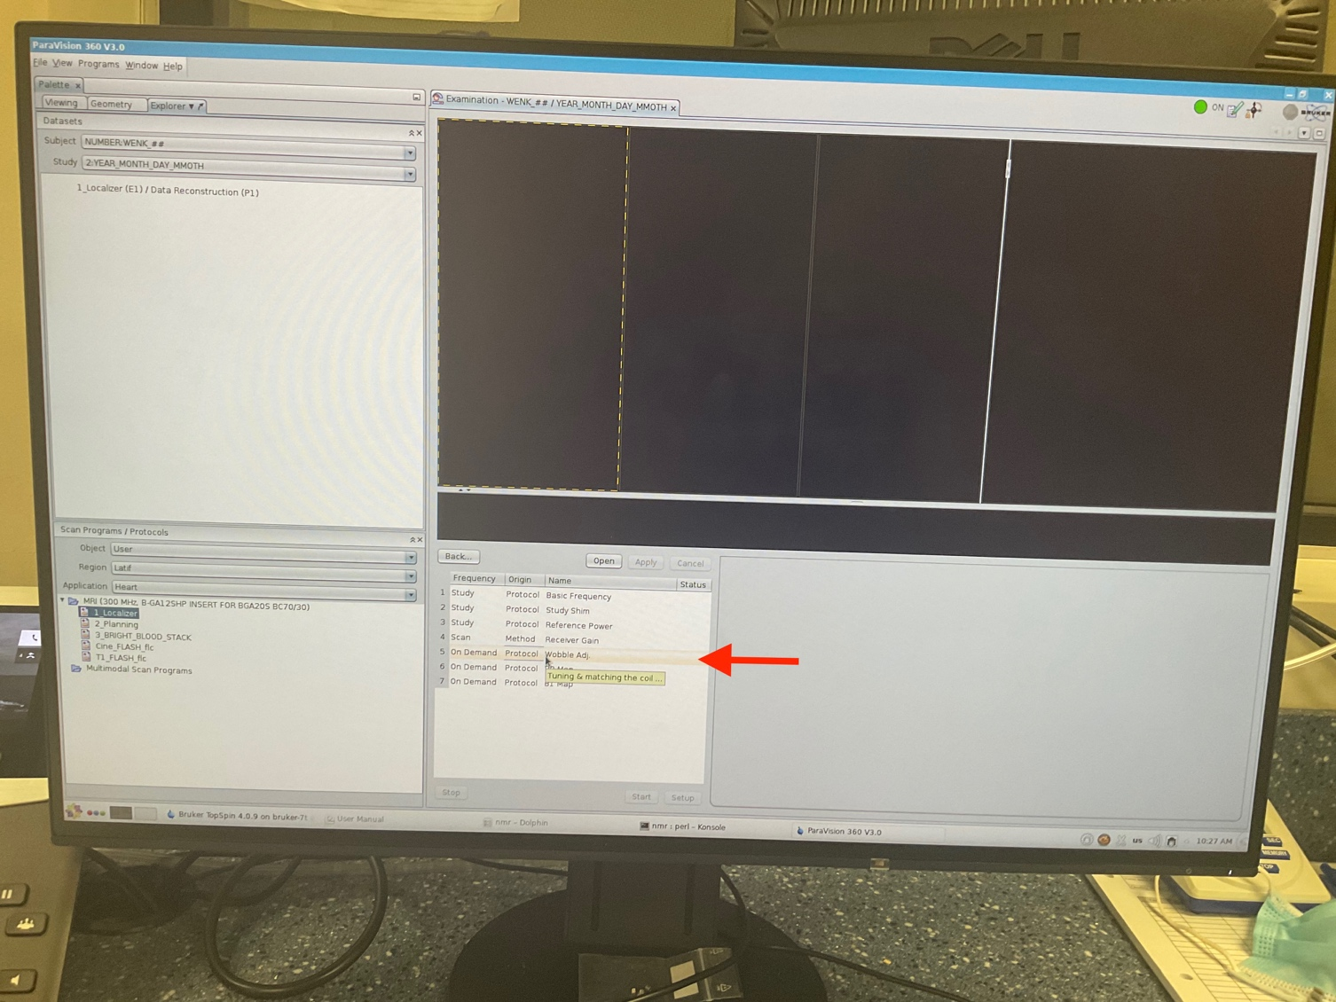

1. Select “Wobble adjustment” shown with the red arrow and “open”.

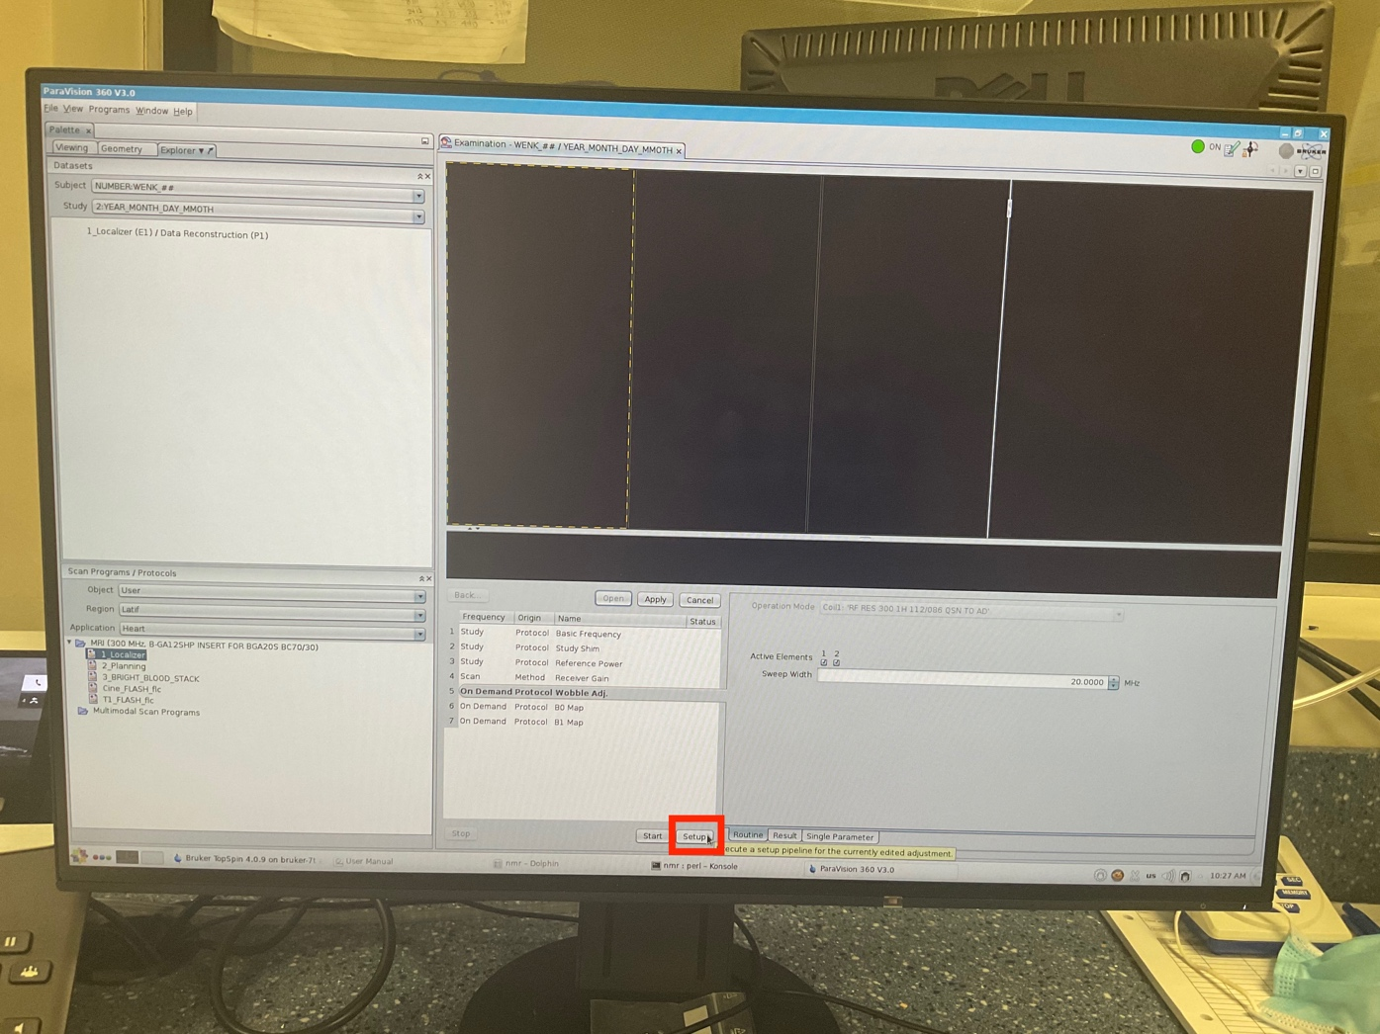

1. Click on “Setup” button to adjust the wobble setting.

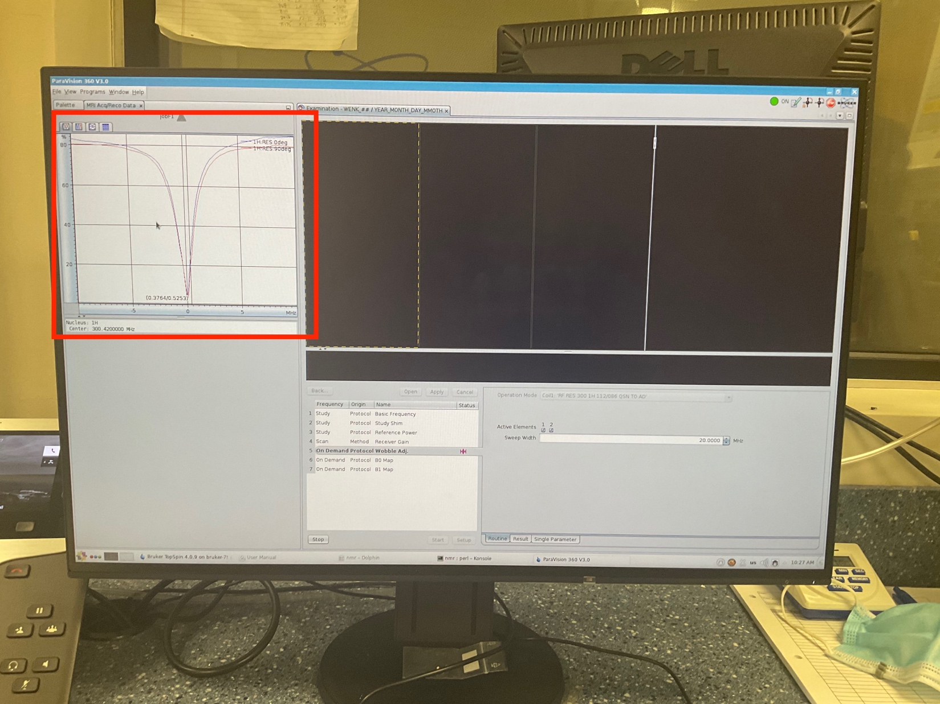

1. Then, the user must go into the scanner room at the behind of the scanner to manually adjust the wobble.
2. The adjustment should be done in a way that:
3. The vertical line would be placed at the center of two diagrams (yellow knobs)
4. The amplitude of diagrams is deep enough to touch the minimum horizontal line/ axis. (green knobs)

16- Then, on the software screen, hit the “stop” button.

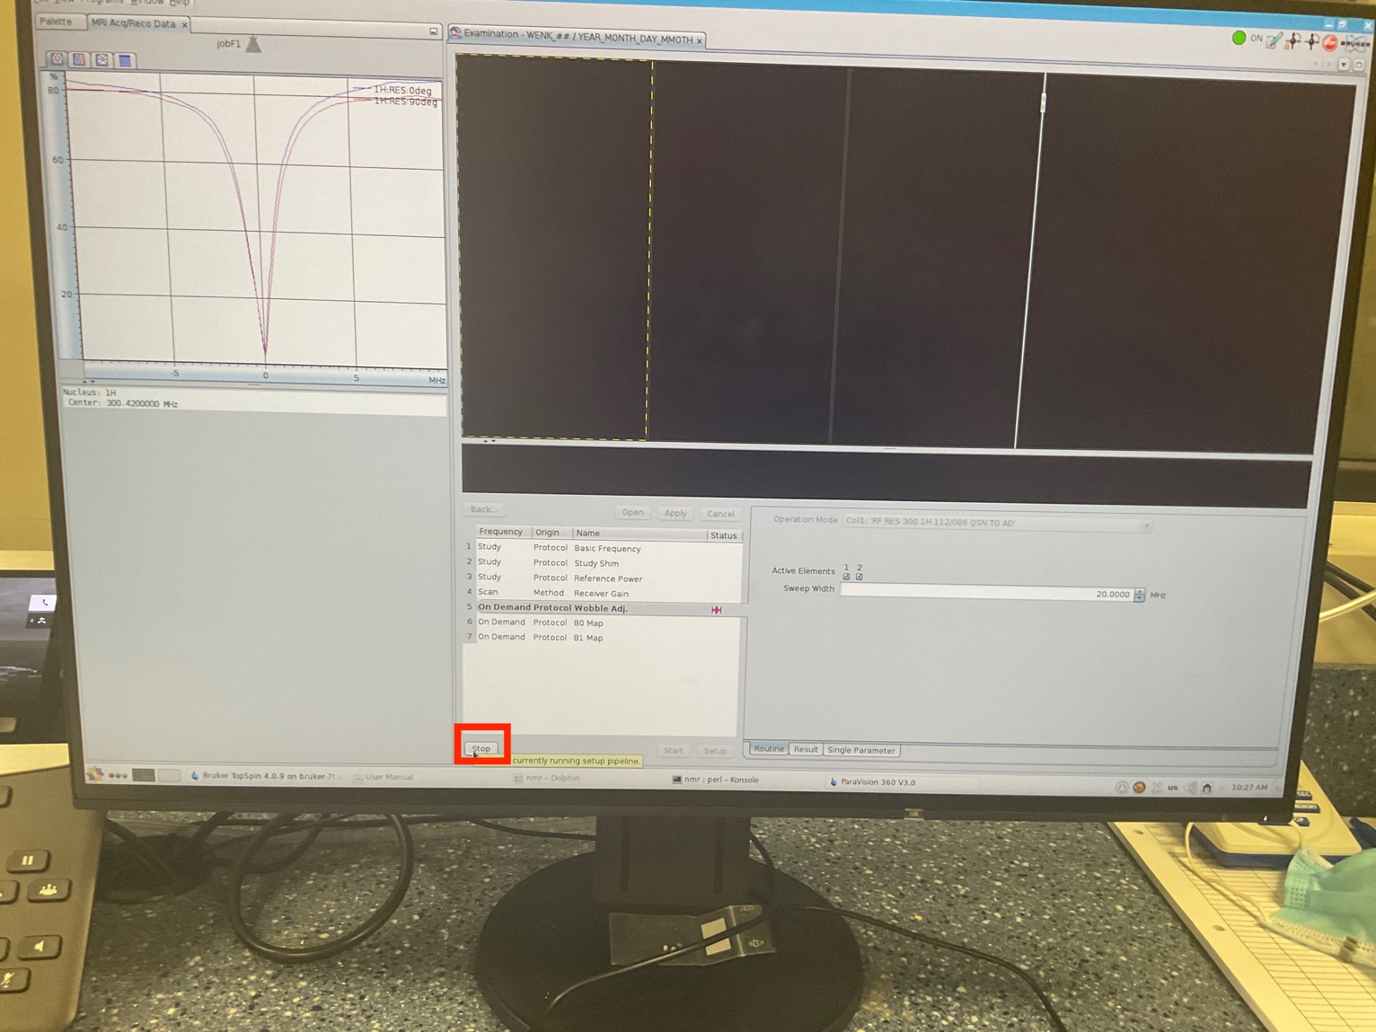

17- Then “Apply” the changes and press “back”.

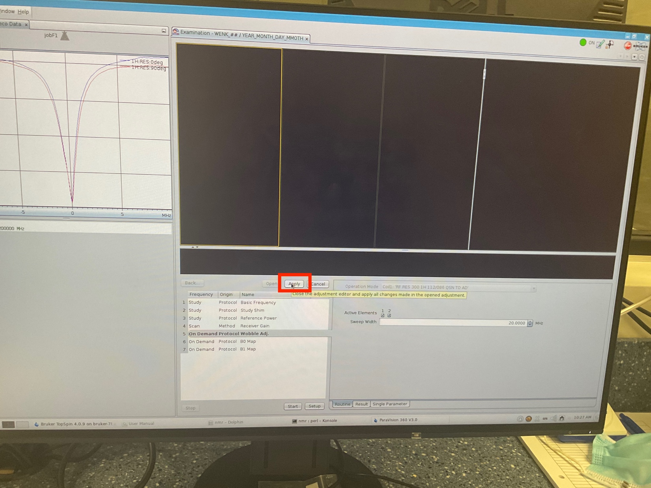

18- Click on continue to allow the scanner to start scanning.

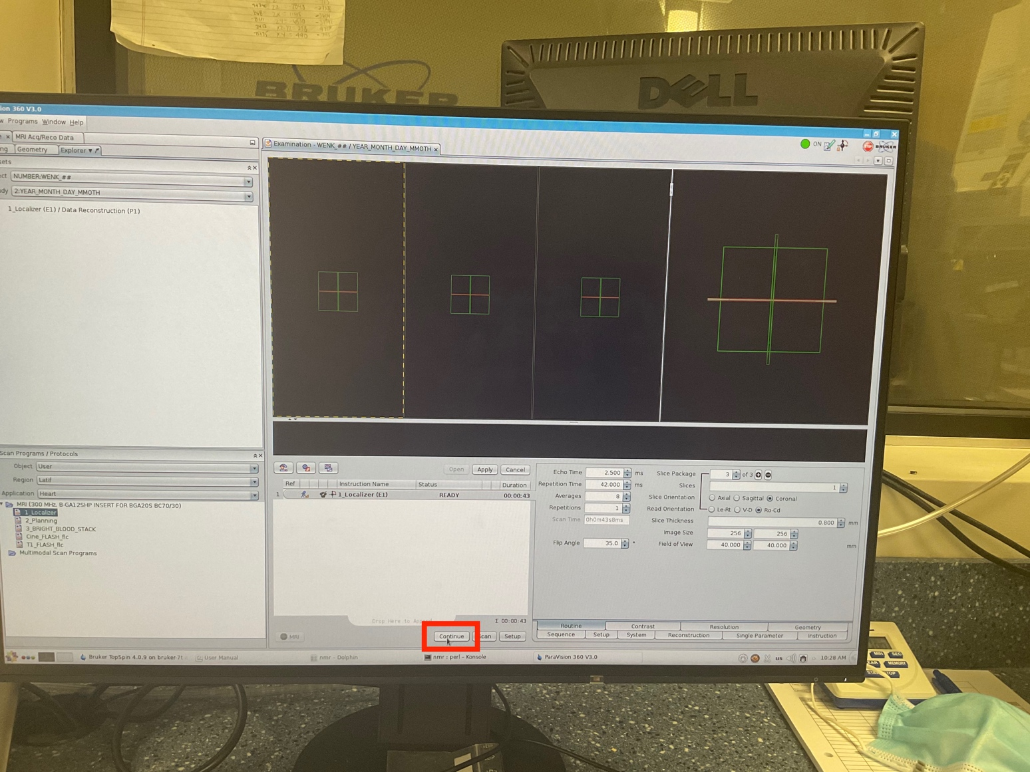

19- Allow the scan to be completed. It usually takes couple minutes.

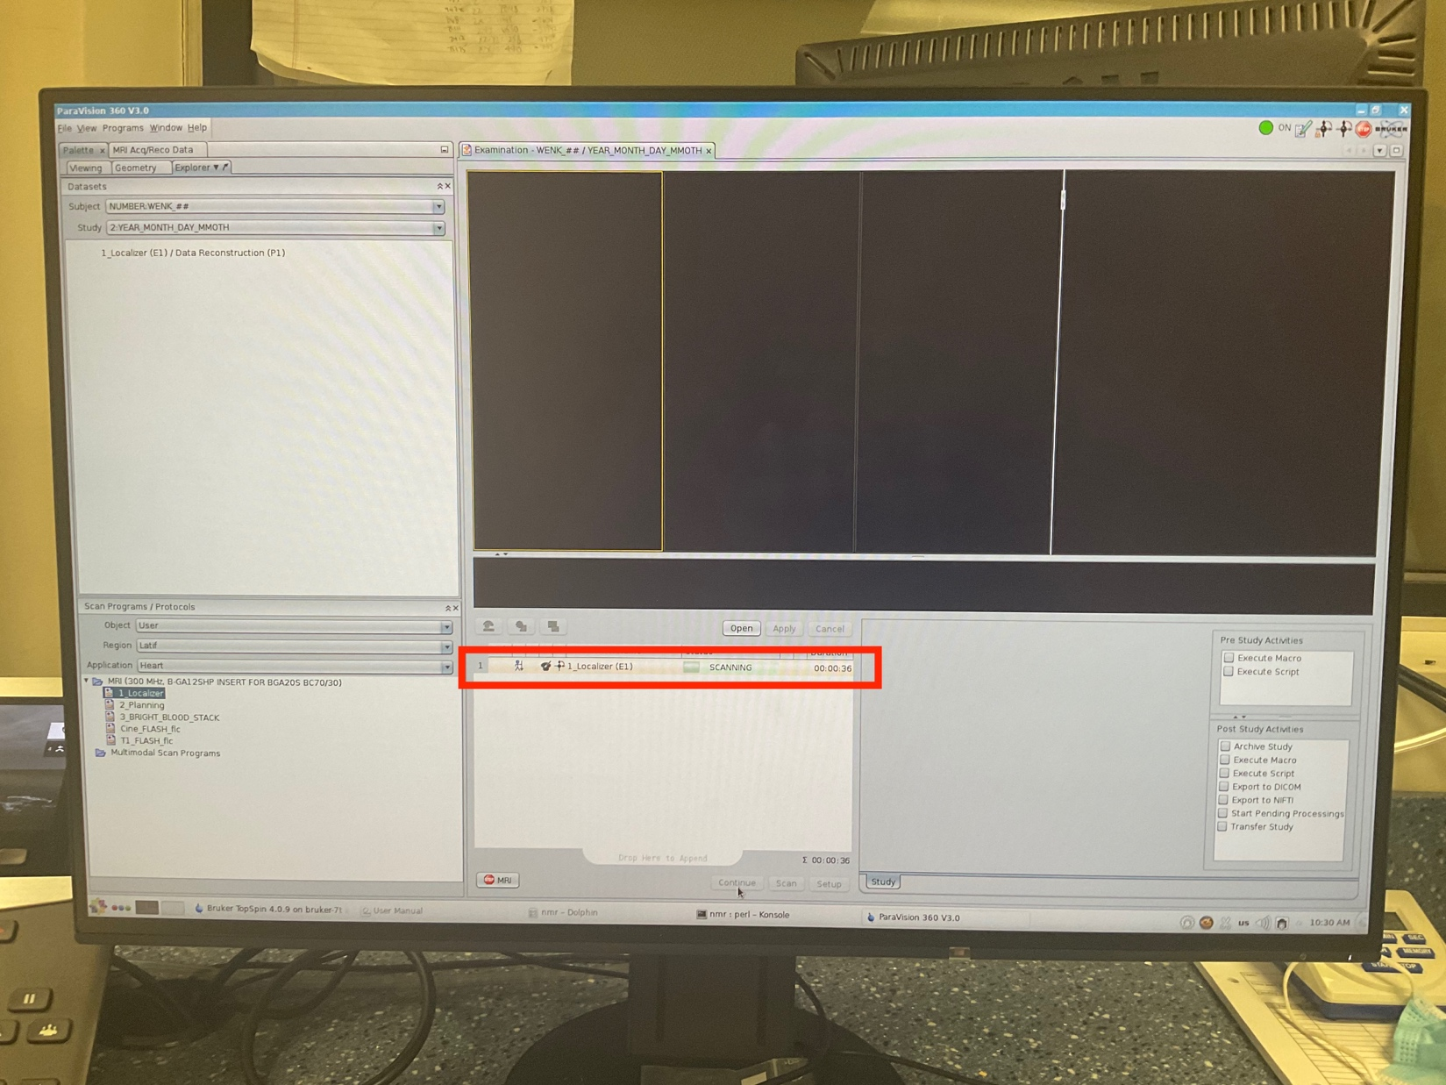

20- When the first step is finished, drag the “planning” step to the middle “operating” window.

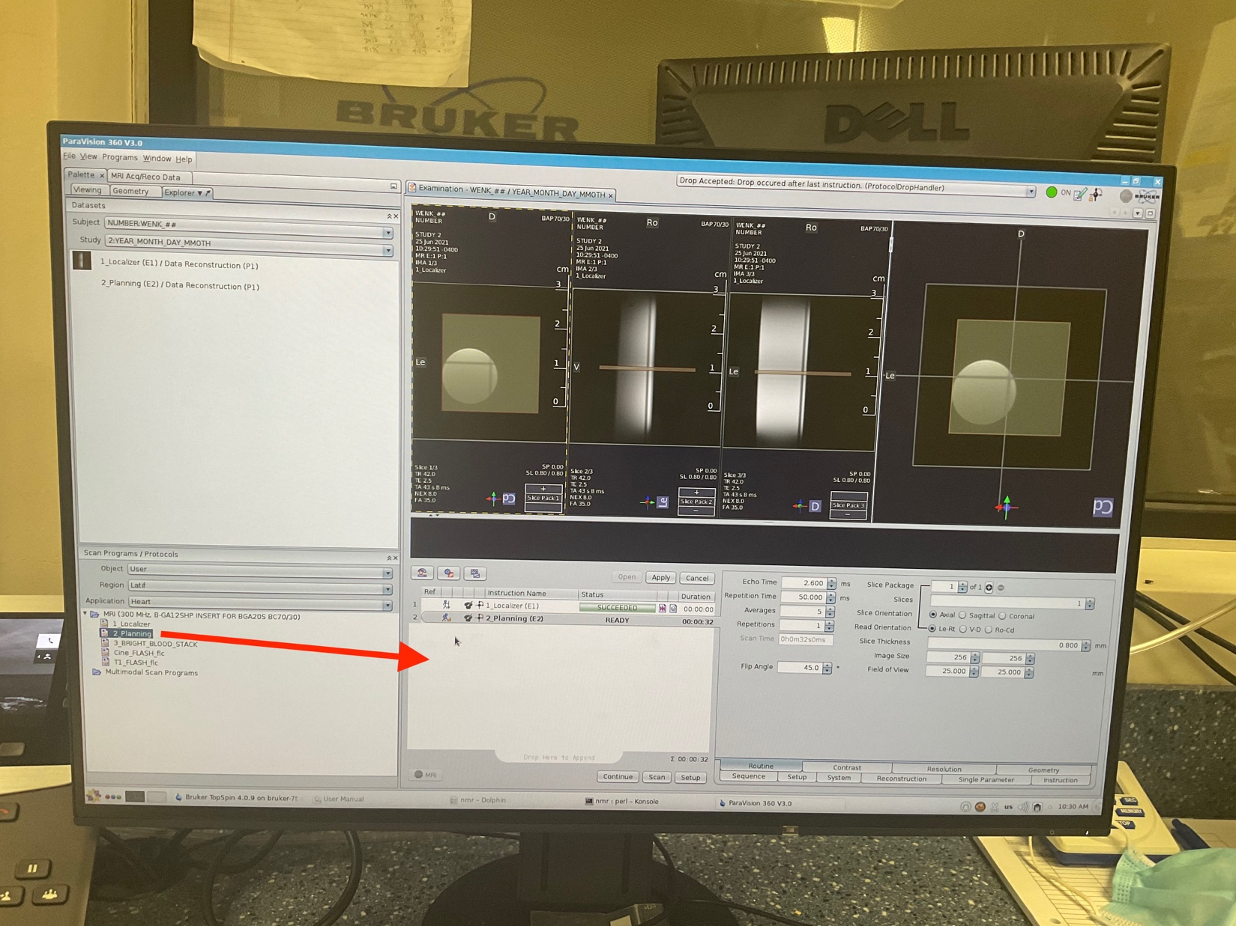21- Adjust the location of imaging “slice” to be in the center of targeted object/organ (e.g. heart).

1. Start with the longitudinal view (second window)

Note: to move the plane, move the cursor to the center point and drag the plane.

Note: To rotate the plane: move curser on the plane, once it shows the rotation sign, you can click and hold to rotate the plane.

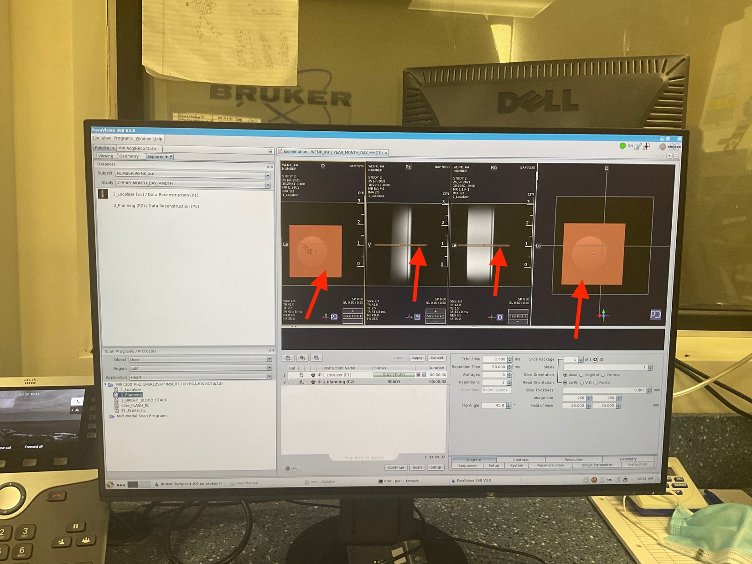

22- Click “continue” to start the scanning.

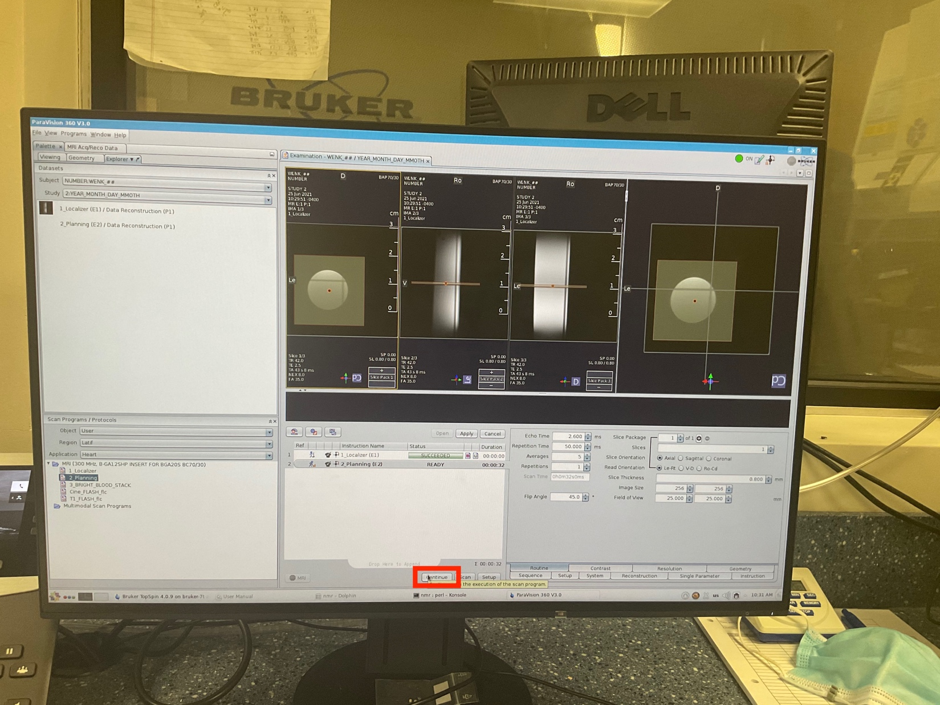

23- Right click on the previous step and select “duplicate”

* Then “rename” the step to “POOR_4CH”

24- adjust the location of plane to cut through the 4 chamber:

* Activate window that shows the acquired image from the previous step (Planning).
* Go to “Geometry” tab, under “Align” panel select the red arrow button to make the slice perpendicular in the “planning” image.
* Manually rotate the slice to get a 4_chamber view.

{ADD picture}

25- Press continue to scan.

26- Duplicate the “POOR_4CH” and rename it to “POOR_2CH”.

27- Adjust the location of the plane to cut through the two chamber view and then press continuue.

Note: Recommended to adjust the slice on the 4_chamber view image. To do that:

I- Make the slice on the 4_chamber window to be perpendicular.

II- Then place the center of the clice on the apex of the heart and adjust it to cut through the 2_chamber view.

III- Then move back the center of the clice to the center of the LV (no more on apex)

Note- Don’t trust the “short axis” views because they may not be appropriately orthogonal. If it was needed adjust the slice on the “short axis” image as well.

28- Duplicate the “POOR_2CH” and rename it to “BASAL_AXIAL”.

29- Move the location of plane to get the short axis view from the basal location. Tip from Dave: Image a line tangent to the mid septum. The short axis slice should be perpendicular to this.

30- “Continue” to start the scan.

31- Duplicate the “BASAL_AXIAL” and rename it to “APICAL_AXIAL”.

32- Then move the location of imaging plane close to the apex to get the apical view.

33- Press "continue” and start the scan.

34- Open “CINE_IG_FLASH” step.

35- Right click on the “BASAL_AXIAL” step and “copy_parameters”

36- Select the destination to “CINE_IG_FLASH”.

NOTE- THESE ARE FOR THE FIRST TIME”

1. Select15 frames for “movie frame”.

37- Rename it to “Cine_IG_FLASH_4_CH”

Instruction ….

37- Rename the step to “Cine_IG_FLASH_1”.

37- On the “Cine_IG_FLASH” image, find the “end-diastole” frame, where the apex is at it lowest location, and move the center of the slice to the bottom of the LV in a way that the bottom slice is at the bottom of LV cavity.

{ADD an image}

38- Duplicate the previous step and rename it “Cine_IG_FLASH_2”.

39- Go to “Geometry” tab, and decrease the “Slice_Offset” to move up the location of slice by 1 slice thickness.

{ADD_an image}

40- Repeat the previous steps until you cover the whole LV. It usually, takes couple of slices to cover the LV.

41- Duplicate the “Cine_ IG_FLASH_4_CH” step and rename it to “Cine_IG_FLASH_2_CH”

1. On the image from “Cine_ IG_FLASH_4_CH” make sure the plane is perpendicular.
2. Move the center of the slice to apex and then rotate the slice along the longitudinal direction.
3. Use the “Cine” short axes images (e.g. basal and apical) for making sure the slice is cutting through the correct 2chamber view.

42- “continue” to start the scanning.

43- Start getting the “third” longitudinal axis.

* To access the “view” tab, the user can do “right_click” on a completed step in the left-top window and select the “view” tab.

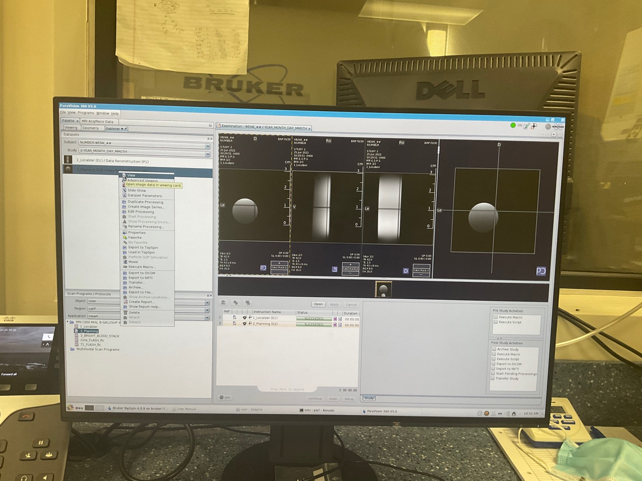

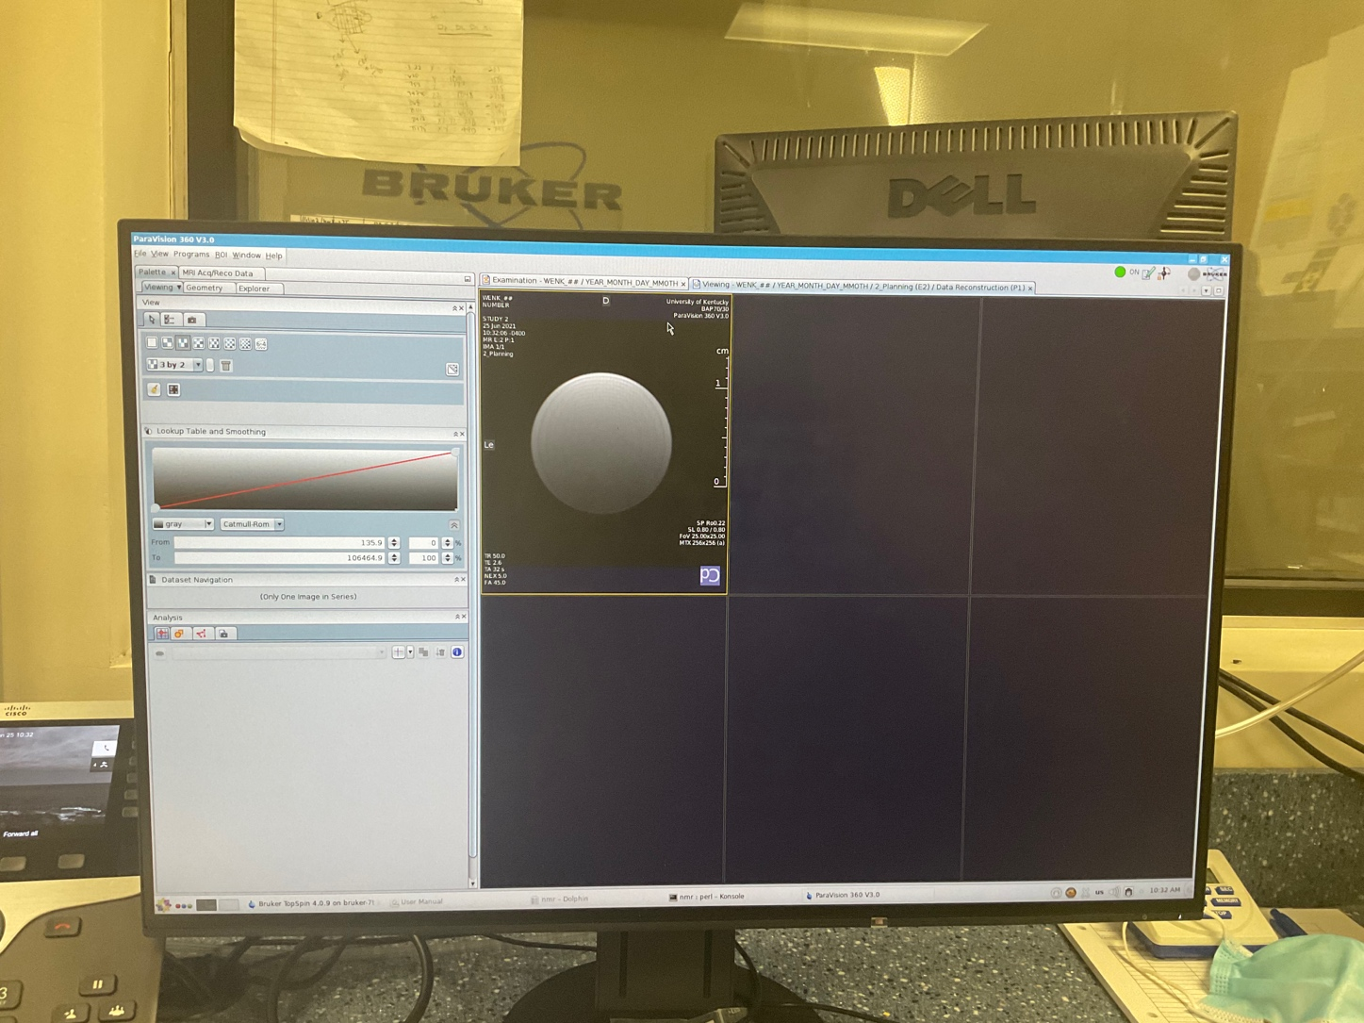

* To access scanned projects and export data:

Window >> “Dataset Browser”

